

SLEIGHTS & SANDSEND

MEDICAL PRACTICE

NEWSLETTER

SPRING 2024

**OUR Performance over the Autumn- Winter period**

**The changing face of General Practice**

Did you know that, in addition to your GP, there are other health professionals working at the Practice who can help you get the right care? Our team is made up of a whole range of professionals, nurses, health care assistants, care coordinators, social prescribers and clinical pharmacists. When you call the Practice, the receptionist will ask questions to enable them to guide you to the most appropriate support and clinician. This may include referring you to Pharmacy First for minor ailments which pharmacists at the local chemist can deal with, suggesting you call physiotherapy at the hospital as you can self refer, suggesting you visit either a dentist or an optician for particular needs.

From 22/09/2023 to 20/02/2024 the Practice has dealt with

**21136** appointments of which **14450** were face to face. **(68%)**

Alongside which we delivered flu and covid vaccinations to all those eligible who required them.

If you need to see a GP you will always be offered an appointment, but there may be other health professionals available who can provide the most appropriate support. Having a range of health professionals at the Practice means you can receive the right care for your condition as quickly as possible.

**ITS GOOD TO TALK, EMAIL, TEXT, PHONE….**

To support this process we have been looking at the ways we communicate with you and the ways you can communicate with us. We have listened to the feedback received from patients regarding the time spent holding on the telephone and in response, we launched a service call Accurx Triage via our Website which enables you to get an appointment and answers to queries quickly and efficiently without the inconvenience of waiting to speak to a receptionist.

This is the most efficient way to request an appointment, submit any non-urgent medical and all admin queries.  
The appointment system will be exactly the same, e.g. we will still have a daily urgent care GP to speak to patients who need same day advice or, if appropriate a face to face appointment.

You will be asked to complete a few simple questions which take just a few minutes to complete (similar to a telephone call). After completion, the request is reviewed by a member of staff who is trained to navigate the query to the most appropriate person (as the receptionist does on the telephone).

* We will respond during working hours Monday to Friday.
* Urgent requests are triaged by a GP on the same day, and you will receive a same day response. (As is the current procedure).
* If you require a routine telephone or face to face appointment, we will inform you of a time and date based on your availability (stated by you on the form) within 2 working days.
* You can request your preferred doctor or nurse for an appointment.
* All other routine requests are responded to within 2 working days.



* You can choose to be contacted by the surgery by telephone, text message or email.

**What are the benefits to you?**

* Requests will quickly be seen by the most appropriate member of staff and dealt with in an appropriate timeframe.
* No more waiting on the telephone.
* Convenience – send your request over whenever you need it, rather than when the phone lines are open.
* Your GP may be able to help more quickly and efficiently.

**What If I do not have access to the internet or struggle to complete online forms?**

* Please telephone the surgery reception as normal and we can deal with your query.
* You can submit a form on behalf of other people if they are unable to do so for themselves.

AS IS THE CURRENT PROCEDURE   
**IF YOU HAVE AN MEDICAL EMERGENCY CALL 999**

In addition to this you can still use Patient access and the NHS app to book appointments, order repeat prescriptions, access your medical records, view immunisations and results and so much more.

We have also introduced the use of text messages to let patients know when their prescriptions are ready for collection to reduce unnecessary trips to the Practice.

You can of course still use the telephone, hand prescription request in at the Practice or ask for advice at reception.

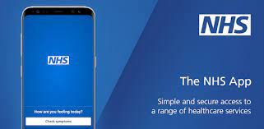

**STAFF CHANGES**

We have a number of recent staff changes to the practice since the last newsletter so just a reminder about the teams and an introduction to new members.

Drs Graeme Little, Simon Stockill, Ros Davies and Matt Shaw continue as the partners in the Practice, Dr Rosie Rayment and Dr Hannah Stephens, who joined us in February 24, are salaried GPs, while Dr Femi Abegundi and Dr Rebecca Foljambe are supporting the Practice as locums.

In other team news Maria Lopez, advanced nurse practitioner left the Practice in December and Dawn Cass joined as an HCA in August. The Practice continues to train registrars and at the moment we have Drs John Ward, Sharjeel Abbas, Innocent Aghalibe, Ahmed Shalabi and Emem Ndekwu working with the Practice.

And finally, just a note on Dr Rory Newman who came out of retirement to support us with Covid clinics and home visits for covid and flu vaccinations – he has finally hung up his stethoscope! The Practice thank him for all his additional hard work and commitment to the cause.

You can find the most up to date information on our website at

Sleightsandsandsendmedicalpractice.nhs.uk

**Staff Training**

Throughout the year we have a series of staff training events, which means the Practice will be closed to patients for the afternoon but if you need medical attention and call the Practice, the phone will be transferred to our out of hours support.

13th March 2024/10th July 2024 /13th November 2024

**WATCH THIS SPACE**

The NHS will be running a Spring 2024 Covid 19 campaign to be delivered between mid-April and the end of June 2024.

Eligible patients will be adults aged 75 and over, residents in a care homes and individuals aged 6 months and over who are immunosuppressed.

Once plans are in place we will provide further information.

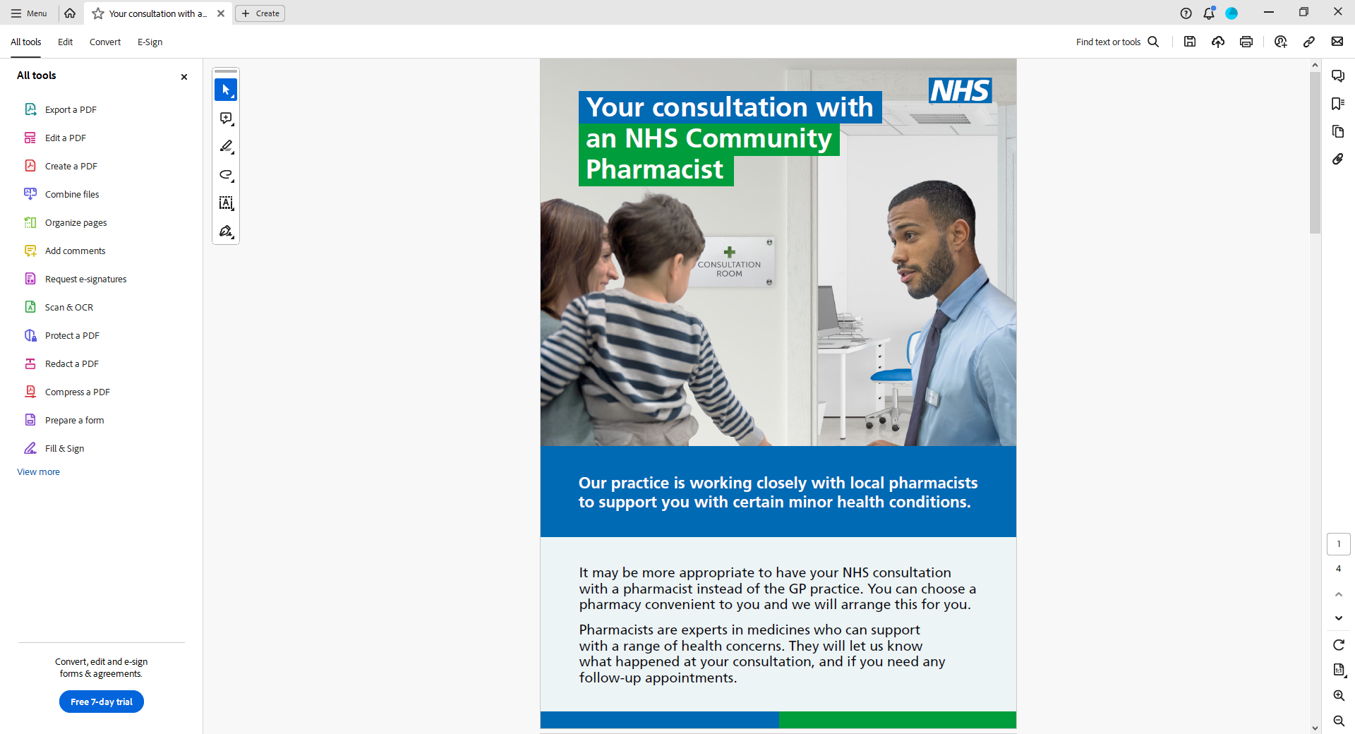

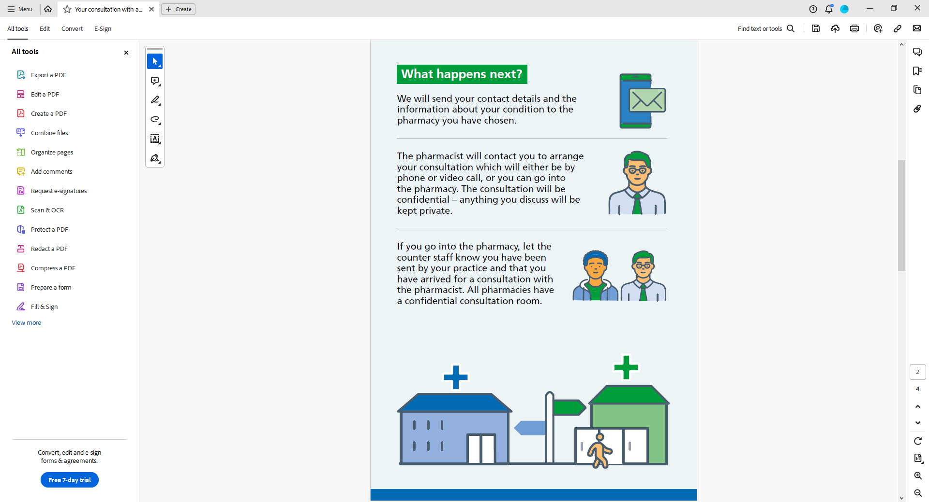

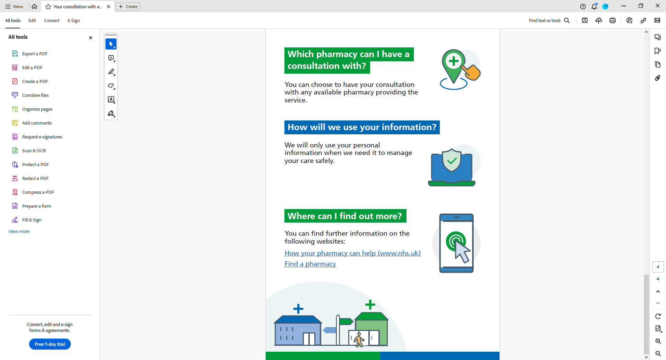

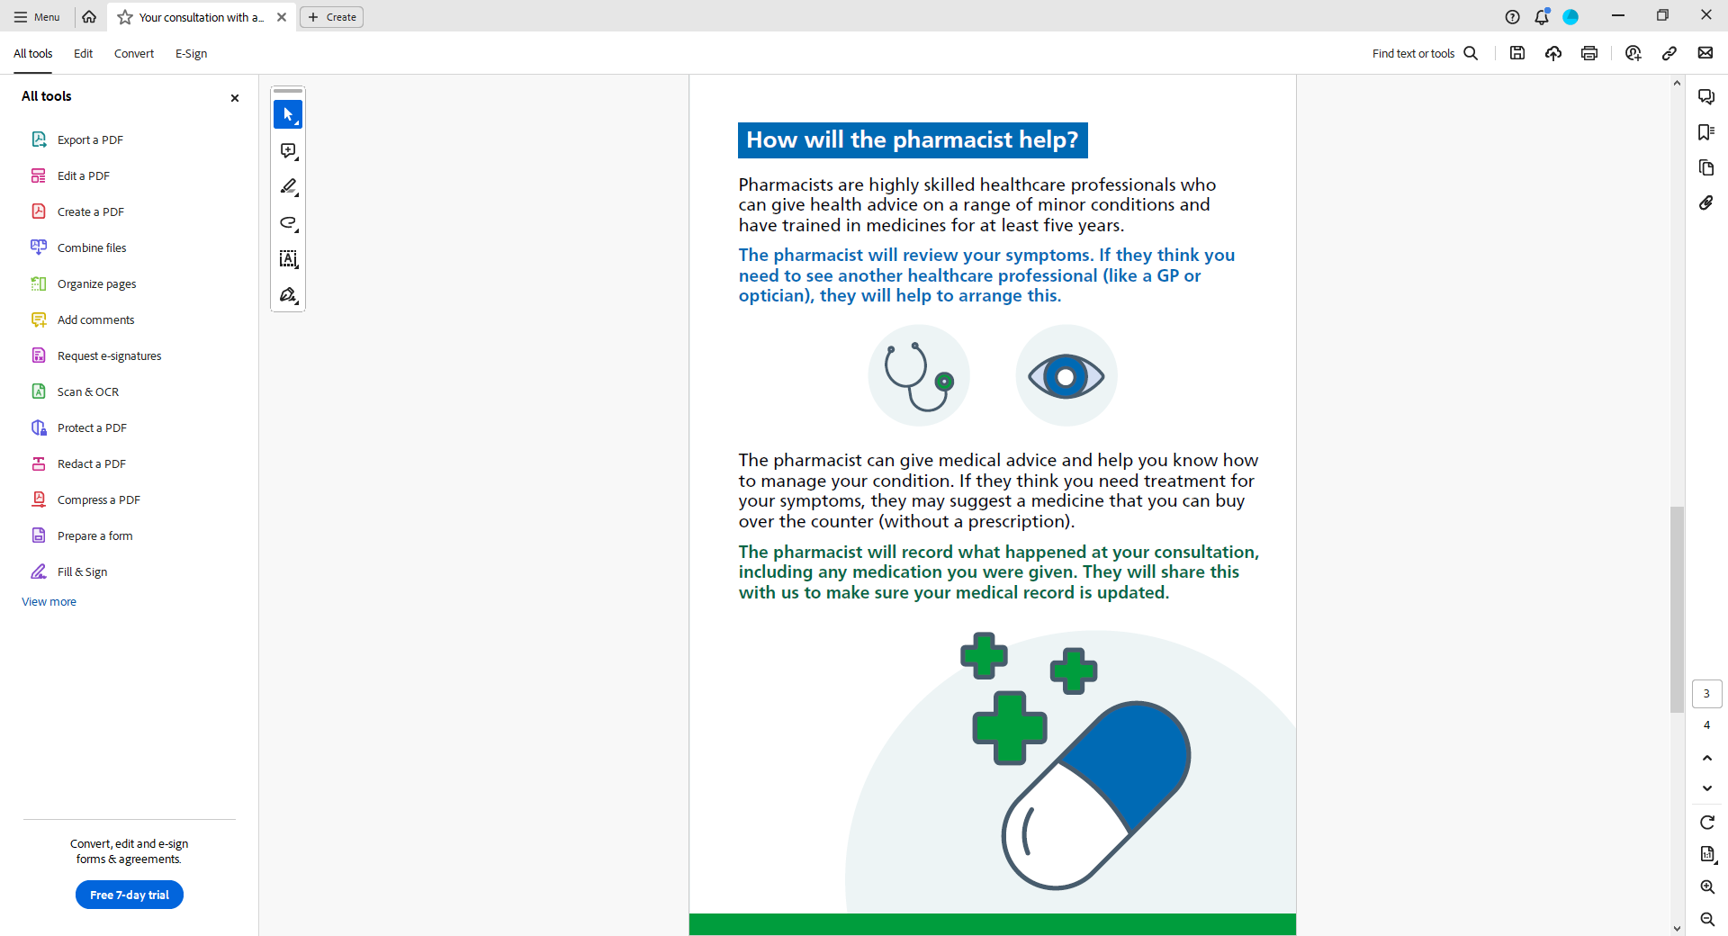

**SSMP COMMUNITY GARDEN**

**“A regular dose of gardening can**

**improve public health.1”**

What a privilege it is to have green space all around Churchfield Surgery. And we wanted to make this space a resource for staff, patients and the community so that the joys of working in, and being in a garden could be shared. Work by a small and doggedly committed group started a year ago: clearing, shredding, planting. Paths and a seating area are almost complete. We want this space to not only enhance our health and well-being but also add biodiversity.

Gardening is good for health. “Studies reported a wide range of health outcomes, such as reductions in depression, anxiety, and body mass index, as well as increases in life satisfaction, quality of life, and sense of community.”1.Masashi S. et al Gardening is beneficial for health: A meta-analysis,Preventive Medicine Reports,Volume 5,2017,Pages 92-99

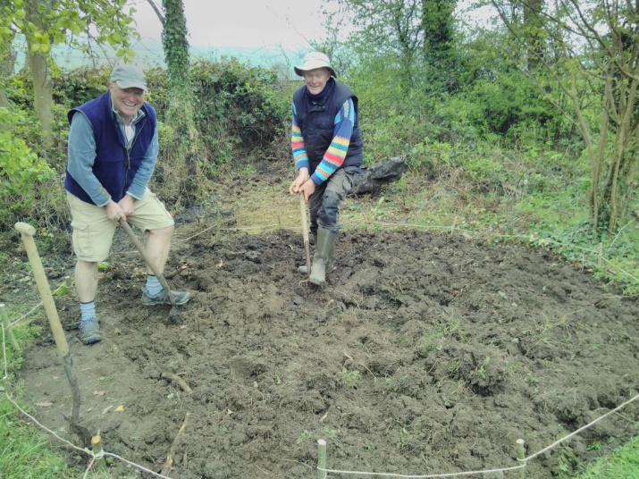

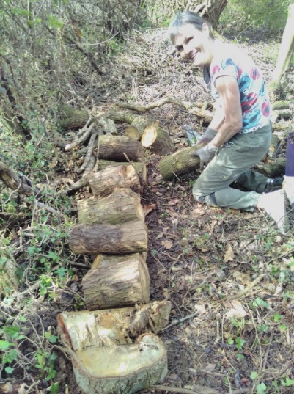

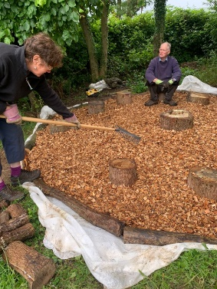

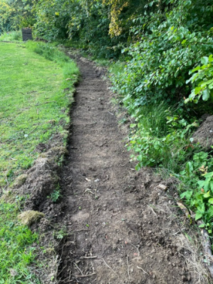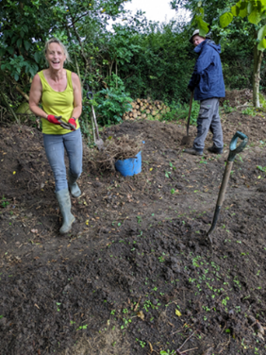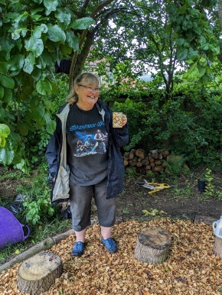

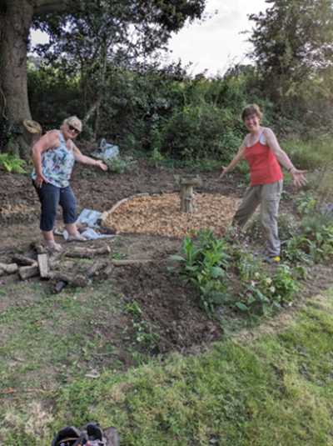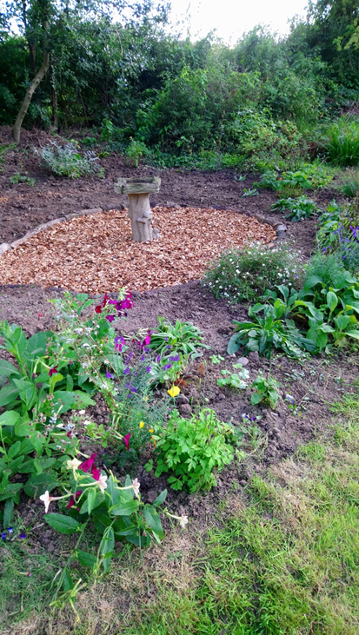

We are very grateful to everyone who has donated plants, materials, money and their time. A special thank you to Wilf Noble Building Supplies who have made the paths and seating areas possible; to Danny Boyes who expertly used a digger, saving us hours of time and hard work; to Whitby Lions for the two water butts; to Sue Cooper for gifting some beautiful pots and the bird bath; to Pauline and John Newbold for their very kind donation; and to Annette Moss and Dorothy Simms for their kind offers of a donation when the garden is ready for them! A special thank you to the Practice Partners for a donation and all their support and willingness to embrace the project.

**We would be delighted for more people to get involved.**

**If you are interested, please contact Suzie Grimoldby at the surgery*,*or email**[**hnyicb-ny.sandsmp-admin@nhs.net**](mailto:hnyicb-ny.sandsmp-admin@nhs.net)

**Laughter, tea/coffee and going home pleasantly tired (and often muddy) is guaranteed. Cake is usually available too!**